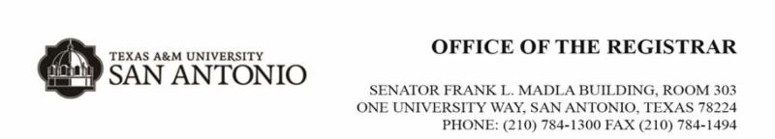
Degrees by College:
College of Arts and Sciences
Undergraduate degrees (BA, BS, and select BAAS degrees):
General Studies
Communications
History
English
Spanish
Biology
Psychology
Chemistry
Mathematics
Electronic Systems Engineering Technology
Water Resources Science and Technology
Criminology/Criminal Justice
Political Science
Sociology
Bachelor of Applied Arts and Sciences:
Water Resources Science & Technology, Bachelor of Applied Arts and Sciences
Criminology and Criminal Justice Concentration
Masters Degrees:
English
Biology
Psychology
Water Resources Science and Technology
Criminology and Criminal Justice
College of Business;
Undergraduate degrees (BBA, BS, and select BAAS Degrees):
BBA and BS Degrees
Accounting
Finance
Computer Information Systems Information Assurance and Security
Computer Information Systems
Computer Science
Cyber Engineering Technology
Cyber Security
General Business
International Management
Management
Marketing
Bachelor of Applied Arts and Sciences
Information Technology Concentration
Information Technology/Information Assurance and Security Concentration
Business Concentration
Fire and Emergency Services Administration-Emergency Medical Services (EMS) Concentration
Fire and Emergency Services Administration-Fire Administration Concentration
Fire and Emergency Services Administration-Homeland Security Concentration
Masters Degrees:
Master of Professional Accounting
Master of Business Administration
Master of Science in Finance
Master of Science in Computer Science
11-Month Master of Business Administration
College of Education
Undergraduate Degrees; Bachelor of Science and select BAAS Degrees:
Applied Behavior Analysis
Human Services
Kinesiology Exercise Science
Kinesiology Exercise Science/Pre-PT
Kinesiology Physical Education (Grades EC-12)
Interdisciplinary Studies Bilingual Generalist (Grades 4-8)
Interdisciplinary Studies Bilingual Generalist (Grades EC-6)
Interdisciplinary Studies Generalist (Grades 4-8)
Interdisciplinary Studies Generalist (Grades EC-6)
Interdisciplinary Studies Special Education (Grades EC-12) with 7-12 Content
Interdisciplinary Studies Special Education (Grades EC-12) with Dual Certification in Generalist (Grades 4-8)
Interdisciplinary Studies Special Education (Grades EC-12) with Dual Certification in Generalist (Grades EC-6)
Child Development
Special Education
Education
BAAS Degrees:
Early Childhood Education Concentration (Non-Certification)
Interdisciplinary Studies Concentration (Non-Certification)
Masters Degrees:
Applied Behavior Analysis
Clinical Mental Health Counseling
Counseling and Guidance: School Counseling
Kinesiology
Marriage, Couple, and Family Counseling
Curriculum and Instruction
Reading
Bilingual Education
Early Childhood
Educational Administration
Special Education

